**Week 9 blog post**

**Topic –**

Week 9 – Animation

**Snapshot of the final product –**

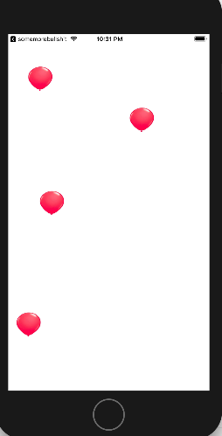

Fig 36: A snapshot of the simulator view of dropping balloons

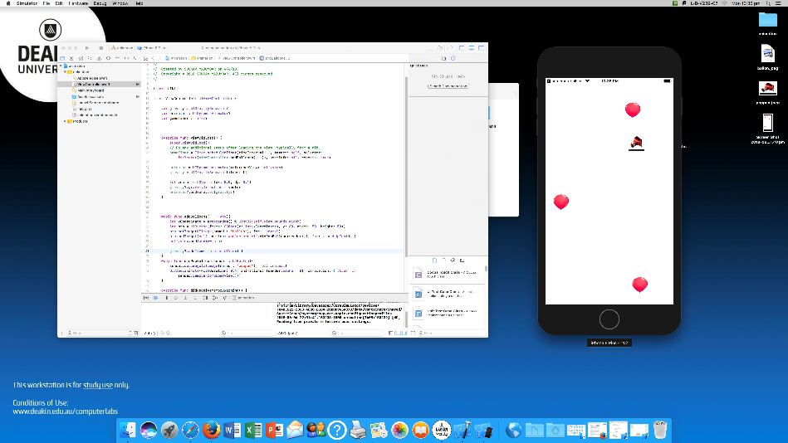

Fig 37: A snapshot of the simulator view showing the balloon popped when the user clicks on it.

**How I implemented –**

For this app first I downloaded the two images of a balloon and a popped balloon and added it to the assets folder. Then added three important variables as shown below.

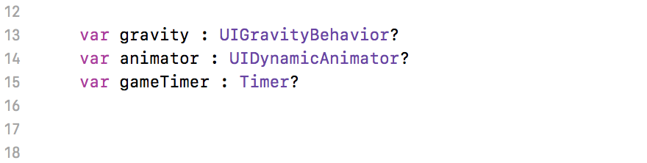

Fig 38: Snippet from the program

After adding the variables in the viewDidLoad function I added different constraints to the variables for the dropping effect of the balloons and time duration, as shown below

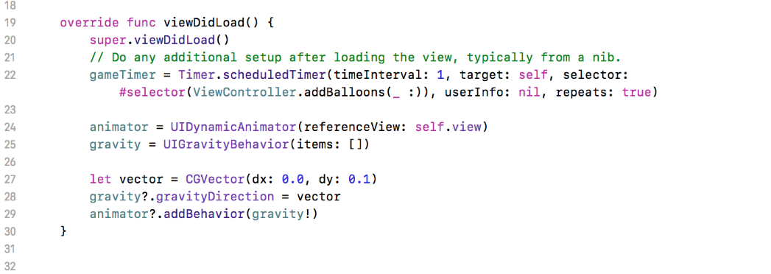

Fig 39: A small snippet of the view did load function.

The addBalloons function keeps on adding ballons on the screen at random position from the top of the screen and also checks if the balloon has been popped. And if the balloon is popped then changes its image. The two functions are shown below.

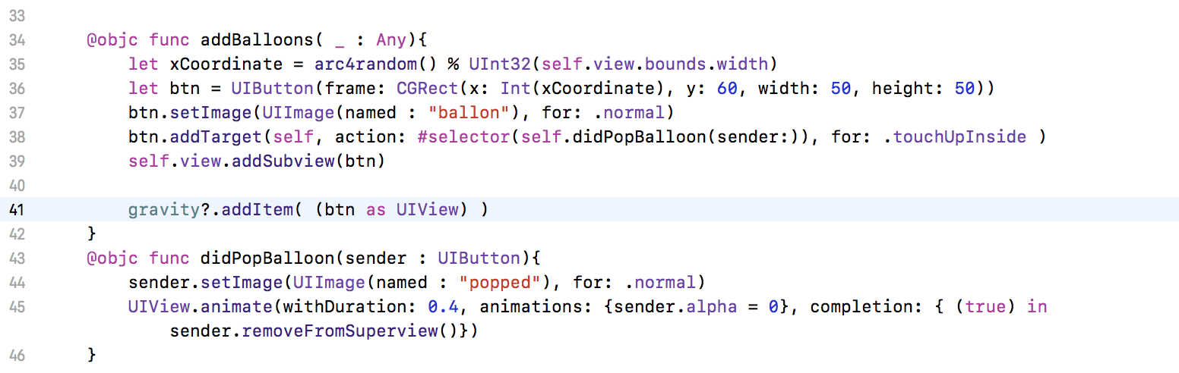

Fig 40: The addBalloons function and the didPopBalloon function.

**Reflection –**

After the end of this week I have finally learnt animation which I can use in my app for assignment 2. In this week I learnt new classes like gravity and animation. While doing this lab I faced problem with the addBalloons function and didpopBalloon function as they were showing errors and after a lot of time with the help of object reference it started to work, hence learnt few more things about referencing functions. There were lot of new functions used in this app, learning every capability would help me make better application in future.